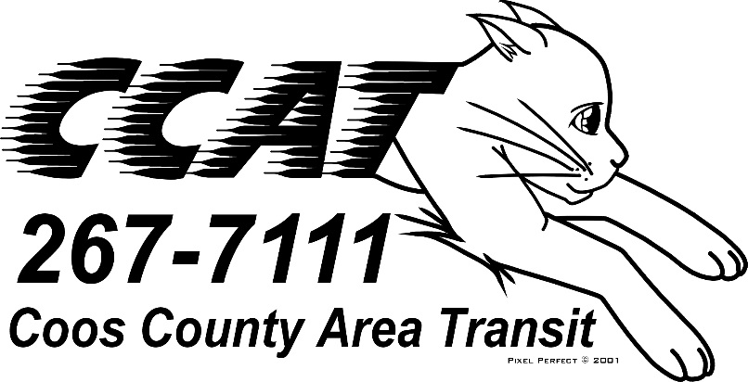

Request for Information for Paratransit and Fixed Route Software
Coos County Area Transportation District (CCATD)
Date Issued | January 20, 2020
Deadline for Questions | January 27, 2020 4:00 pm Pacific Time
Answers to Questions to be posted | February 3, 2020 4:00 pm Pacific Time
Response to RFI Due | February 10, 2020 4:00 pm Pacific Time

RFI Document 1/20/2020
REQUEST FOR INFORMATION (RFI) FOR TRANSPORTATION SOFTWARE
Responses are hereby requested by the Coos County Area Transportation District (CCATD) 2810 Ocean Blvd SE, Coos Bay Oregon, 97420 to be received until 4:00 pm Pacific Time, on February 10, 2020 for Paratransit and Fixed Route Software.

Requests for clarification and/or questions concerning this RFI should be directed to David Hope via email dhope@coostransit.org. All submittal questions concerning this RFI are due by January 27, 2020 4:00 pm Pacific Time. The RFI is available on the CCAT website http://www.coostransit.org/.

SECTION 1:

1.1. GENERAL REQUIREMENTS

This is a Request for Information (RFI) only and does not constitute a commitment, implied or otherwise, that CCAT will take procurement action in this matter. Further, CCAT will not be responsible for any costs incurred in furnishing the requested information; all costs associated with responding to this RFI will be solely at the interested party’s expense. No award will be made based on the results of this process.

Interested parties should submit a response to Section 2.2 - Request for Information.

Upon release of this RFI, all communications should be via E-mail to David Hope, General Manager dhope@coostransit.org. The subject line of the email should read “2020 RFI Paratransit and Fixed Route Software” to ensure that the response is properly identified and evaluated by CCAT. Responses to this RFI should be submitted in Portable Document Format (PDF). Please note that CCAT’s file size limitation is 35MB.

1.2. SUBMITTAL

Responders to this RFI should try to limit responses to 10 pages (35 MB or less) including a cover letter that is signed by an officer authorized to submit the response on behalf of the firm. CCAT will only accept email RFI responses. The email should contain the following information:

- Identification of proposing firm(s), including name, address, telephone number(s), and email address.
- Name, title, address, telephone number, and email address of the contact person for the project.
- Response to Section 2.2

1.3. ADDENDUM TO RFI

If it becomes necessary to revise this RFI, any addendums will be posted on the CCAT website and/or sent to those having expressed an interest in submitting a response.

1.4 QUESTIONS/REQUESTS FOR CLARIFICATIONS
CCAT will respond to Questions and Requests for clarifications to those parties who have expressed interest in this RFI and will post any responses on the CCAT website.

SECTION 2: PROJECT DESCRIPTION

2.1. BACKGROUND

CCAT is responsible for the administration and operation of paratransit and transit service in Coos County Oregon. CCAT currently provides service on five (5) fixed routes and five (5) paratransit routes.

CCAT utilizes the following to provide service:
- Easy Ride paratransit scheduling software
- Seon camera system
- Diamond Manual fare box
- Two way radio system

2.2. REQUEST FOR INFORMATION

CCAT is open to innovative and flexible solutions that have been previously deployed in other locations. CCAT is interested in systems which have a reasonable cost of entry, are easily maintained, and provide a user-friendly experience.

Please submit a brief description that provides information on your company’s capabilities and experiences pertaining to the items below. (It is not necessary to respond to each item)

I. General
- How does your application facilitate rider-focused technologies?
- How does your application utilize GPS capabilities to facilitate ride scheduling?
- How does your application optimize routes and schedules?
- How does your application manage rider fares and/or donations?
- Please provide references for other customers currently using your program.
II. User Experience/User Interface and Communications
- How is your application made available to employees?
- How does your application allow customers to manage and view their profiles and trips in the system?
- How does your technology support online/app-based booking or requesting of trips by users?
- How does your application disseminate ride notifications to users?
- How does your application offer real-time trip information to customers?
- How does your application allow both drivers and riders to understand trip length, trip time, costs (if applicable), and estimated time of arrival and location of the driver?
III. Manifests
- How does your application communicate driver manifests?
- Do you offer the option of auto-emailing manifests?
- How are rider’s mobility needs or limitations communicated to the drivers on the manifest?
- Please provide a sample manifest.
IV. Data and Reporting
- What are the system’s reporting capabilities?
- What types of reports does your system generate?
- Can reports be customized by the users?
- What types of metrics does the system track?
- How will the system import and export data?
V. System Security and Confidentiality
- How does your program protect confidential customer information?
- Please describe your HIPAA compliance policy.
- How is your application hosted? Locally on premises or in the cloud?
VII. Support and Cost
- What is your cost structure?
- How do you charge for system modifications or customizations?
- Please describe your start up/implementation costs.
- What is your application licensing model?
- Please provide complete overview of all costs associated with the system as well as additional costs that may be incurred.
- Describe your customer service policy, how quickly you respond to requests for system service and the hours you are available.
- How frequently do you update your mapping software? Is there a cost?
- How will your application make our system more efficient and save money?
VIII. Mode
- How does your application facilitate demand response transportation?
- How does your application facilitate fixed route transportation?

